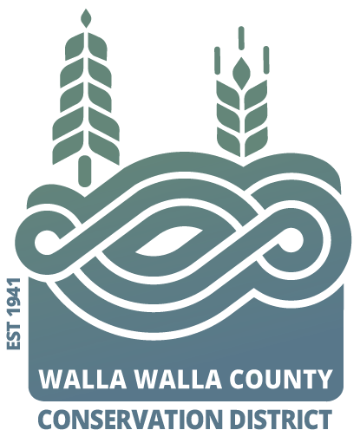
AGENDA
for the Walla Walla County Conservation District
Board of Supervisors Meeting
Monday June 10, 2024 at 5 p.m.
via Zoom & USDA Service Center conference room,
325 North 13th Avenue, Walla Walla WA

Call to Order..................................................................................Chair Kent
Welcome Visitors!
Request for Public Comments:
Minutes of May Board Meeting*
Financial Report*

NEW BUSINESS
- Partner updates (NRCS, WSU Ext., WDFW, WACD, and/or SCC) …Hadley
- Annual review of Board effectiveness……………………………… Hadley
  - Rotation of board positions
- *Resolution acknowledging vacancy in mid-term elected position…..Hadley
  - Determine the dates of the four-week period for applicants to apply;
  - Describe the minimum requirements of applicants.
- *Annual review of ‘vendor list’ for routine expenses……………….Freer
  - Add WW Transmission Specialist
- Review & Approve* FY25 Addendum with SCC...………………Hadley
- Discussion and edit pay date……………………………………..Freer
- Discussion of July meeting options……………………………..Hadley/Freer
- Discussion of area engineering…………………………………Hadley
PROGRAM UPDATES
- Hadley: District Operations

Misc. Discussion & Public Comments:

Adjourn……………………………………………………………….. Chair Kent

